**XYZ BANK**

**Banking Management Syﬆem**

**Business Requirements Document**

**V1.0**



|  |  |  |  |
| --- | --- | --- | --- |
|  | **Prepared By /** | **Reviewed by** | **Approved By** |
|  | **Laﬆ Updated** |  |  |
|  | **By** |  |  |
|  |  |  |  |
| **Name** | Hemanshu Solanki |  |  |
|  |  |  |  |
| **Role** | Project Leader |  |  |
|  |  |  |  |
| **Signature** | Hemanshu |  |  |
|  |  |  |  |
| **Date** | 12/08/2016 |  |  |
|  |  |  |  |

**Table of Contents**

1. **Introduction 3**
   1. **Purpose of this document 3**
   2. **Project Overview 3**
   3. **Scope 3**
      1. In scope 3
      2. Out Scope 3
   4. **Intended Audience 3**
   5. **Conﬆraints, Assumptions and Dependencies 4**
2. **Organization Architecture 4**
   1. **XYZ Bank 4**
   2. **COGNIZANT 4**
3. **Process Architecture 5**
4. **Business Process Analysis 7**
   1. **Current Scenario 7**
      1. ‘As-is’ Process Flow **7**
      2. Process Flow Details **8**
   2. **Proposed Solution 8**
      1. ‘To-be’ Processes **8**
      2. Process Flow Details **9**
5. **Process Definitions 9**
   1. **Business Rules 9**
6. **Detailed Business Requirements 10**
7. **Business Process to Requirements Traceability 11**
8. **Objective and Expectation Traceability 11**
   1. **Business Objective Traceability Matrix 11**

**9.0** **References 12**

**10.0 Change Log 12**

1. **Introduction**
   1. **Purpose of this document**

This document is aimed at

* + Providing the necessary inputs to the detailed requirements gathering phase and further on for the SDLC processes.
  + This document also serves to eﬆablish the traceability between the Business

Objectives and the requirements identified in the proposed solution and how they satisfy the ﬆated objectives.

* + Provide expectation traceability in terms of the requirements and the user expectation
  + Serves as a formal template for documenting the Business Requirements which also includes ﬆatutory and regulatory requirements.

1. **Project Overview**

Banking Management Syﬆem consiﬆs of several operations and processes to be done on several accounts simultaneously, better performance is ensured only when these processes are executed and the results are put to eﬀect within a small time window. Achieving this is impossible when bank operations are done through paper work whereas an automated syﬆem is capable of providing the required performance and also has the potential of scalability. Creating such a syﬆem is the main intent of this project.

1. **Scope**
   1. **In scope**
      * Create and maintain bank account information.
      * Regiﬆering cuﬆomers
      * Applying loans
      * Making Transactions
      * Updating cuﬆomer profile
      * Generating bank ﬆatements and reports
   2. **Out Scope**
      * Notification Syﬆem
2. **Intended Audience**
   * + - All associates going for the initial ﬆudy at new accounts/projects.
       - Associates preparing the white papers/proposals for these accounts/projects.
       - Delivery Assurance Group, Process Engineering group

**1.5** **Conﬆraints, Assumptions and Dependencies**

**Assumptions:**

* After developing the application, new cuﬆomers can be regiﬆered into the syﬆem.
* There will be no current users for the application once the application is developed.
* Any changes to the requirements mentioned in the BRD would be taken as a change requeﬆ.

**Dependencies:**

* If any other application has to work with this syﬆem, it muﬆ be reusable.

**Conﬆraints:**

* + - Application should have single login feature.
    - None of the application features can be accessed without login.

1. **Organization Architecture**
   1. **XYZ BANK**

|  |  |  |  |  |  |  |
| --- | --- | --- | --- | --- | --- | --- |
| **Name &** | **Primary Responsibilities** | **Module** | **Primary Responsibilities** | | | |
| **Position** | **(relative to project)** |  | **(relative to application** | | | |
|  |  |  | **business process)** | | |  |
| Bank | Manager | Bank | Laying | down | rules | and |
| Manager |  | Management | regulations | |  |  |
|  |  | Syﬆem |  |  |  |  |
| Bank | Adminiﬆrative Officers | Bank | Adminiﬆering the syﬆem. | | | |
| Employees |  | Management |  |  |  |  |
|  |  | Syﬆem |  |  |  |  |
| Account | Users | Bank | Users | of | the | Bank |
| Holders |  | Management | Management Syﬆem | | |  |
|  |  | Syﬆem |  |  |  |  |
|  |  | Services |  |  |  |  |

1. **COGNIZANT**

|  |  |  |  |  |
| --- | --- | --- | --- | --- |
| **Name &** | **Primary Responsibilities** | | **Module** | **Primary Responsibilities** |
| **Position** | **(relative to project)** | |  | **(relative to application** |
|  |  |  |  | **business process)** |
| Delivery | Responsible | for timely | Employee | Laying down HR policies |
| Manager | delivery of project | | Management |  |
|  |  |  | Syﬆem |  |
| Architect | Defining the | architecture | Employee | Setting down the rules |
|  | and design of the syﬆem | | Management |  |
|  |  |  | Syﬆem |  |

**3.0 Process Architecture**

**Physical Architecture:**

A physical architecture is an arrangement of physical elements, (syﬆem elements and physical interfaces) that provides the designed solution for a product, service, or enterprise. It is intended to satisfy logical architecture elements and syﬆem requirements. Bank Management System follows a three layered architecture namely presentation layer, business logic layer and data access layer.

The major back end processes related to the syﬆem are

* **Regiﬆer new cuﬆomers**

The cuﬆomers have to regiﬆer with the syﬆem in order to make use of the syﬆem.

* **Apply loan**

Once the cuﬆomers have regiﬆered with the syﬆem, they have an option to apply for loan.

* **Make transactions**

Cuﬆomers can make any kind of transactions like withdrawal, deposit and transfer to other accounts of same bank or other bank.

* **Update user profile**

User details such as contact, residence address, etc tend to change over time. Hence to support such changes, cuﬆomers have an option to update their user profile anytime.

* **Generate bank statement**

Bank ﬆatements are useful in various scenarios such as a proof document to show that the cuﬆomer is active, etc.

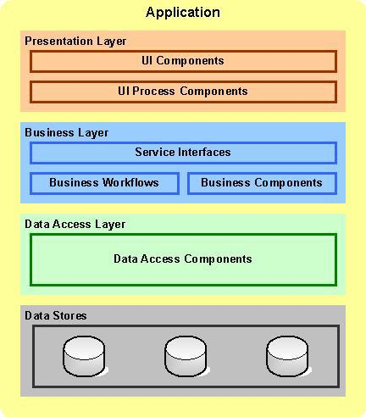

**Logical Architecture:**

The Logical Architecture defines the Processes (the activities and functions) that are required to provide the required User Services. Many diﬀerent Processes muﬆ work together and share information to provide a User Service. The Processes can be implemented via software, hardware, or firmware. The Logical Architecture is independent of technologies and implementations.

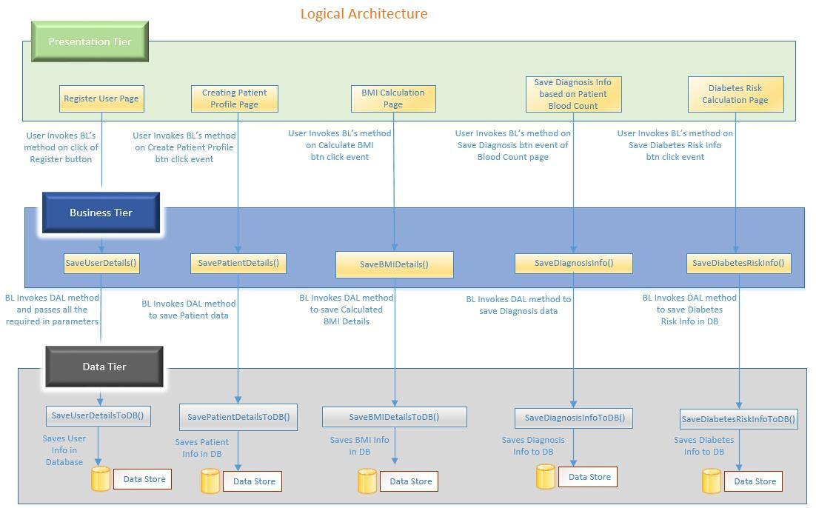

1. **Business Process Analysis**
   1. **Current Scenario**
2. **‘As-is’ Process Flow**

As per the current process, the cuﬆomer has to visit the bank for opening an account, for carrying out transactions or for availing any other services oﬀered by the bank. This consumes lot of cuﬆomer time and eﬀort, and manual resource of the bank. So a new syﬆem is required to automate these banking services and operate at cuﬆomers’ convenience.

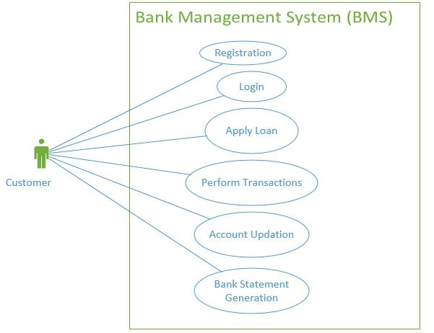

1. **Process Flow Details**

The following can be included here

* + - Process measurement points and measurements
    - Process problems
    - Roadblocks to process improvement
    - Internal process requirements
    - Elapsed cycle time and activity cycle time

1. **Proposed Solution**
   1. **‘To-be’ Processes**

Once registered with the syﬆem, the cuﬆomer can setup his profile and then requeﬆ for services.

* + 1. **Process Flow Details**
       - Creating Account for the user to access the portal.
       - Account holder profile creation.
       - Updating profile.
       - Making transactions.
       - Generating Bank Statements

1. **Process Definitions**
   1. **Business Rules**

Business rules should be defined using the following attributes:-

* Business rule could be either a term or a conﬆraint.
* Business rule could be a ﬆatement that defines or conﬆraints key aspect of the business
* Business rule should be 'atomic' so that it cannot be broken down or decomposed further into more detailed business rules

|  |  |  |  |
| --- | --- | --- | --- |
| **#** | **Rule Name** | | **Definition** |
| 1 | Account | Holder | The Account holder name should contain only |
|  | name |  | alphabets and space. |
| 2 | Mandatory Fields | | All fields are mandatory. |
| 3 | Loan ID |  | The Loan id should be automatically generated by |
|  |  |  | the syﬆem and format should be ‘L-XXX’.XXX |
|  |  |  | should be numeric of 3 digits. |
|  |  |  |  |
| 4 | Loan | Account | Loan Account number will be generated |
|  | Number |  | automatically and should be a numeric of 16 |
|  |  |  | digits. |
| 5 | Loan Apply Date | | Loan apply date should not be lesser than syﬆem |
|  |  |  | date. |
| 6 | Loan Issue Date | | Loan issue date should be greater than or equal to |
|  |  |  | syﬆem date. |
| 7 | Time to issue loan | | Loan has to be issued within 30 days from the loan |
|  |  |  | apply date. |
| 8 | EMI Calculation | | EMI should be calculated by using the following |
|  |  |  | formula and updated in the table |
|  |  |  | The formula for calculation of EMI given the loan, |
|  |  |  | term and intereﬆ rate is: |
|  |  |  | EMI = (p*r) * (1+r)^n / (1+r)^n - 1 |
|  |  |  | p = principal (amount of loan), r = rate of intereﬆ |

|  |  |  |  |
| --- | --- | --- | --- |
|  |  |  | per inﬆalment period, i.e., if intereﬆ is 12% p.a. r = |
|  |  |  | 1, n = no. of inﬆalments in the tenure, ^ denotes |
|  |  |  | whole to the power. Alternatively, the reader can |
|  |  |  | use `Calculate EMI function' in EXCEL spread |
|  |  |  | sheet |
| 9 | Initial | Deposit | Initial deposit amount should be numeric greater |
|  | Amount |  | than zero and should contains only positive |
|  |  |  | values. |
| 10 | Loan Type |  | Loan type can be Personal or Housing or |
|  |  |  | Educational. |
| 11 | Duration of loan | | Duration of Loan can be 5,10,15,20 years only. |

1. **Detailed Business Requirements**

|  |  |  |  |  |  |  |  |
| --- | --- | --- | --- | --- | --- | --- | --- |
| **Business** | **Software** | **Short** | **Requireme** | **Priority** | **Complexity** | **Require** | **Remarks** |
| **Requireme** | **Requireme** | **Description** | **nt Provider** |  |  | **ment** |  |
| **nt ID** | **nts ID** |  | **(Originator** |  |  | **type** |  |
|  |  |  | **)** |  |  |  |  |
|  |  |  |  |  |  |  |  |
| BR001 | SR001 | Cuﬆomer | Client | High | Medium | UI | - |
|  |  | Regiﬆration |  |  |  | screen |  |
|  |  |  |  |  |  | & |  |
|  |  |  |  |  |  | backend |  |
|  |  |  |  |  |  | process |  |
|  |  |  |  |  |  | ing |  |
| BR002 | SR002 | Apply Loan | Client | Medium | Medium | UI | - |
|  |  |  |  |  |  | screen |  |
|  |  |  |  |  |  | & |  |
|  |  |  |  |  |  | backen |  |
|  |  |  |  |  |  | d |  |
|  |  |  |  |  |  | proces |  |
|  |  |  |  |  |  | sing |  |
|  |  |  |  |  |  |  |  |
| BR003 | SR003 | Transaction | Client | High | Medium | UI | - |
|  |  |  |  |  |  | screen |  |
|  |  |  |  |  |  | & |  |
|  |  |  |  |  |  | backen |  |
|  |  |  |  |  |  | d |  |
|  |  |  |  |  |  | proces |  |
|  |  |  |  |  |  | sing |  |
|  |  |  |  |  |  |  |  |
| BR004 | SR004 | Update Profile | Client | Medium | Medium | UI | - |
|  |  |  |  |  |  | screen |  |
|  |  |  |  |  |  | & |  |
|  |  |  |  |  |  | backen |  |
|  |  |  |  |  |  | d |  |
|  |  |  |  |  |  |  |  |

|  |  |  |  |  |  |  |  |
| --- | --- | --- | --- | --- | --- | --- | --- |
|  |  |  |  |  |  | proces |  |
|  |  |  |  |  |  | sing |  |
|  |  |  |  |  |  |  |  |
| BR005 | SR005 | Bank | Client | High | High | UI | - |
|  |  | Statement |  |  |  | screen |  |
|  |  | Generation |  |  |  | & |  |
|  |  |  |  |  |  | backen |  |
|  |  |  |  |  |  | d |  |
|  |  |  |  |  |  | proces |  |
|  |  |  |  |  |  | sing |  |
|  |  |  |  |  |  |  |  |

1. **Business Process to Requirements Traceability**

|  |  |  |
| --- | --- | --- |
| **Sno.** | **Business Process** | **Business Requirement** |
| 1 | Regiﬆering a cuﬆomer | Deals with creating an account |
|  |  | for the cuﬆomer. |
| 2 | Applying loan | About applying loan |
| 3 | Update user Profile | Updating current information |
|  |  | in the syﬆem. |
| 4 | Making transactions | Doing all possible transactions |
|  |  | using the syﬆem. |
| 5 | Generating Statement | Bank ﬆatements can be |
|  |  | generated. |

1. **Objective and Expectation Traceability**
   1. **Business Objective Traceability Matrix**

|  |  |  |  |  |  |  |  |  |  |  |
| --- | --- | --- | --- | --- | --- | --- | --- | --- | --- | --- |
| **Business** | |  | **Business** | **Priority** | **Requirement** | |  | **How** |  | **Status** |
| **Objective** | |  | **Requirement** |  | **Title** |  | **requirement** | | |  |
|  |  |  | **Number** |  |  |  | **satisfies** | | |  |
|  |  |  |  |  |  |  | **objective** | | |  |
| To | create | an | 1 | High | Creation | of | Collect | | user | Open |
| account for the | | |  |  | cuﬆomer |  | information | | |  |
| cuﬆomer | | in |  |  | accounts. |  | using | | UI, |  |
| order to use the | | |  |  |  |  | validate | | with |  |
| Bank | |  |  |  |  |  | input |  |  |  |
| Management | |  |  |  |  |  | ﬆandards, | |  |  |
| Syﬆem portal | | |  |  |  |  | ﬆore | in | the |  |
|  |  |  |  |  |  |  | database | |  |  |
| To | apply | for | 2 | High | Using | Bank | Users log in to | | | Open |
| loan, | make | |  |  | Management | | the | syﬆem | |  |
| transactions | |  |  |  | Syﬆem |  | and | uses | the |  |

|  |  |  |  |  |  |  |
| --- | --- | --- | --- | --- | --- | --- |
|  |  |  | services | UI to | opt for |  |
|  |  |  |  | the | services |  |
|  |  |  |  | oﬀered | |  |
| Updating user | 3 | High | Updating the | Users log in to | | Open |
| profile |  |  | user | the | syﬆem |  |
|  |  |  | information | and | updates |  |
|  |  |  |  | the details | |  |

**9.0** **References**

N/A

**10.0 Change Log**

|  |  |
| --- | --- |
| **Version** | **Changes Made** |
| **Number** |  |
| V1.0.0 | Initial baseline created on 08-AUG-2016 by Hemanshu Solanki |
|  |  |